**Quality of Life (QOL) vs. US Crime & Incarceration Rates**

*Create a write-up summarizing your major findings. This should include a heading for each "question" you asked of your data, and under each heading, a short description of what you found and any relevant plots.*

1. **How does incarceration rates compare across regions with varying population densities? (Octavia)**

We began this analysis with the assumption that higher population density is synonymous with lower QOL. With this assumption in place, we assumed higher densities would lead to higher crime and incarceration rates.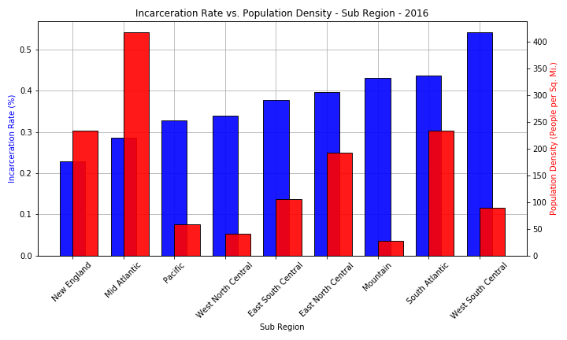

We compared incarceration rates and population densities across all U.S. regions in the year 2016. The results debunked our hypothesis. The regions with the highest population densities had the lowest incarceration rates.

Referencing the figure above, we were led to believe that there is a disproportionate relationship between incarceration rates and population densities in the South, particularly in the South Atlantic and East North Central sub-regions. The reasoning for this is outside the scope of this project.

The above graph provided visual proof that there is a difference in regionalized incarceration rates. To further prove this point statistically, we chose to perform an ANOVA test. 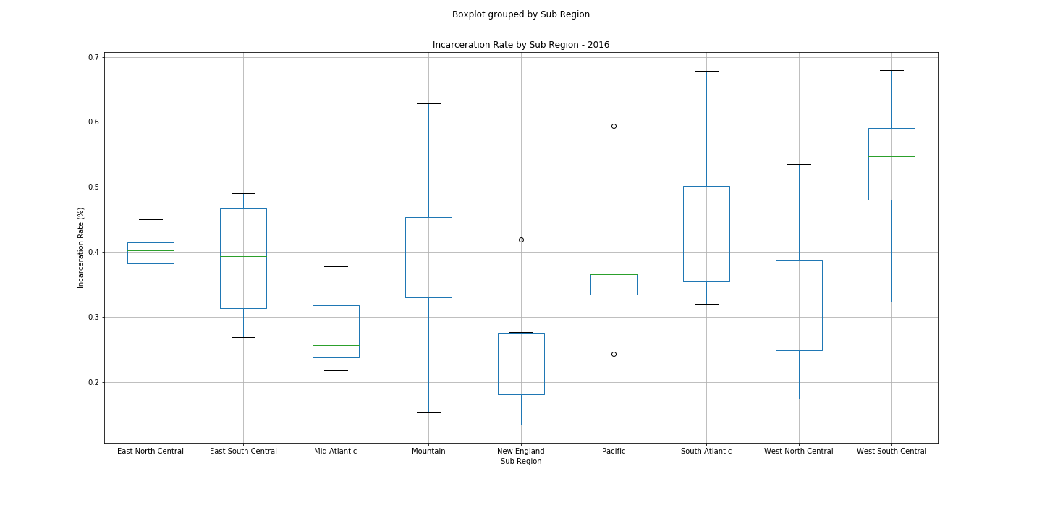

The figure to the right depicts the 2016 incarceration rates for all 50 states, grouped by sub-region. The test yielded a 0.03 p-value. With a 95% confidence level, we concluded that there are significant statistical differences between the incarceration rates of regions with varying population densities.

1. **Does poverty and/or labor have any impact on crime rates in a given state? (Sadia)**
   * Through analysis of the line graphs, one may find that crime levels decrease as poverty levels increase. Which was a really analysis to explore because the question that needs to be answered next is why? Additionally, as the level of labor increased, total crime decreased. Which was an supported our hypothesis. If more people are in employment there will not be any time or more people within the population to commit crime. Lastly, because poverty seems to still be an issue in the United States we took it amongst ourselves to explore the poverty rates throughout the years. We expected or hoped that poverty levels would decline throughout the years. However, after statistical analysis by means of ANOVA we found no significance and many outlier (Figure 1). A potential outlier to consider is that poverty levels differ across the region.

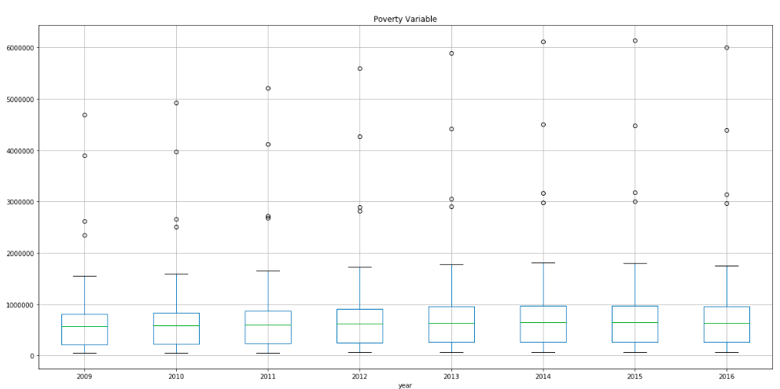

Figure 1:

1. **Does education have any impact on crime rates in a given state? (Amanda)**

After gaining access to both male and female education data, I created a linear graph to ensure both variables were trending in the same direction (Figure 1). The variables I selected showcase male and female age 25 and older with a Bachelor's degree or higher.

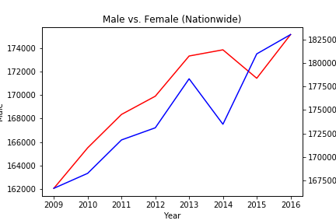

The drastic decline for female education (blue) in 2014 is most likely associated with legislative changes. The same is likely true for males (red) in the following year. In this section, we are assuming that quality of life (QOL) is defined by one's level of education, and higher education levels lead to a decrease in crime in a particular state.The data plots below prove that as education or quality of life increases, crime rates decrease. 